Active Predicate

✅ What Is an Active Predicate?
# Source: AI Source: Provided by: [Data Path: Persons Table -> ID Column: 1, Name_En Column: Motasem Essam] -> From: [ChatGPT] on [8/4/2025]
An Active Predicate is a predicate in which the subject performs the action expressed by the verb.
This is the most common and direct sentence structure in English.

🔸 Key Features:
# Source: AI Source: Provided by: [Data Path: Persons Table -> ID Column: 1, Name_En Column: Motasem Essam] -> From: [ChatGPT] on [8/4/2025]
- The subject is the doer of the action.
- The verb is in the active voice (not passive).
- Often includes a verb + object structure.

🔸 Structure:
# Source: AI Source: Provided by: [Data Path: Persons Table -> ID Column: 1, Name_En Column: Motasem Essam] -> From: [ChatGPT] on [8/4/2025]
Subject + Verb (+ Object/Complement/Modifiers)

🔸 Examples of Active Predicates:
# Source: AI Source: Provided by: [Data Path: Persons Table -> ID Column: 1, Name_En Column: Motasem Essam] -> From: [ChatGPT] on [8/4/2025]
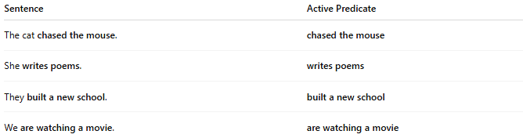
Sentence | Active Predicate
The cat chased the mouse. | chased the mouse
She writes poems. | writes poems
They built a new school. | built a new school
We are watching a movie. | are watching a movie

🔸 Active vs Passive Comparison:
# Source: AI Source: Provided by: [Data Path: Persons Table -> ID Column: 1, Name_En Column: Motasem Essam] -> From: [ChatGPT] on [8/4/2025]
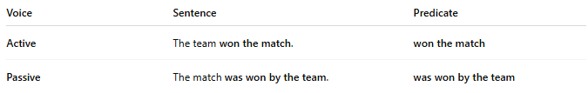
Voice | Sentence | Predicate
Active | The team won the match. | won the match
Passive | The match was won by the team. | was won by the team

🔸 Why It Matters:
# Source: AI Source: Provided by: [Data Path: Persons Table -> ID Column: 1, Name_En Column: Motasem Essam] -> From: [ChatGPT] on [8/4/2025]
- Active predicates make writing clearer, stronger, and more concise.
- They’re preferred in academic, journalistic, and everyday communication.

